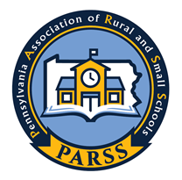
William and Debrah Pettigrew Scholarship

Bill Pettigrew will provide a donation of $10,000 to be utilized for an annual $1,000 scholarship for a graduating high school student who wishes to attend college to become a teacher. Both Bill and his late wife Debrah, worked over 50 years in public education. Debrah was a speech and language instructor, and Bill was a long-time superintendent of schools and an original, and founding father member of the PARSS board
The criteria for submissions are as follows:
- Student must have a cumulative high school 2.5 GPA or better
- Submission of a merit essay describing academic and professional goals including why those goals were chosen and what has been done thus far to prepare for postsecondary education (300-900 words; 2-4 pages)
- Express a clear intent to pursue a career in teaching.
- Student must be accepted for enrollment to a four-year institution for teacher preparation
The chosen essay will be presented to the individual with a check and certificate during the Pennsylvania Association of Rural and Small Schools Conference at the Wyndham Hotel in Boalsburg, Pa.April 30, 2026 .
Name:______________________________Address:___________________________
Email/Phone _______________________________School District________________
Submit essay and above information to:
Dr. Edward Albert ealbert@parss.org
DEADLINE FOR ABOVE INFORMATION IS FEBRUARY 1, 2026

